REST API Integration Guide
Service: AI Data Utility API
Purpose: Provide simple REST APIs that allow an AI Agent or external systems to retrieve current time, current date, date-time information, and a list content pages from published materials.
The Base URL will depend on the deployment environment.
Example:
https://stonecurators-backend.com:3000/api/aiData/gettime
1. API Overview
Endpoint | Method | Description | Authentication
/aiData/gettime | GET | Get the Vietnam current time | No
/aiData/getdate | GET | Get the Vietnam current date | No
/aiData/getdatetime | GET | Get the Vietnam current date and time | No
/aiData/get-material-content-pages | GET | Get content pages from published materials | Yes

2. Response Format
All APIs return responses in a standard JSON format.
Success Response
{
"data": {}
}
Error Response
{
"error": true,
"message": "Error message"
}

3. API Details

3.1 Get Vietnam Current Time
Endpoint
GET /aiData/gettime
Description
Returns the Vietnam current time.
Example Request
GET https://stonecurators-backend.com:3000/api/aiData/gettime
Example Response
{
"data": "14:35:46"
}

3.2 Get Vietnam Current Date
Endpoint
GET /aiData/getdate
Description
Returns the Vietnam current date.
Example Request
GET https://stonecurators-backend.com:3000/api/aiData/getdate
Example Response
{
"data": "2026-03-06"
}

3.3 Get Vietnam Current Date and Time
Endpoint
GET /aiData/getdatetime
Description
Returns the Vietnam current date and time.
Example Request
GET https://stonecurators-backend.com:3000/api/aiData/getdatetime
Example Response
{
"data":"2026-03-06 14:36:39"
}

3.4 Get content pages from published materials
Endpoint
GET /aiData/get-material-content-pages
Description
Returns a list of content pages from published materials that are marked as published in the system.
This API is designed to allow AI agents or external applications to:
- search for content pages from published materials
- display available content pages from published materials
- support chatbot product search functionality
Only material content pages with the following condition will be returned:
published = true

Authentication
This endpoint requires API Key authentication.
The API key is validated using:
authController.validateKey()
The key should be included in the request header.
Example Header
x-api-key: a7f3e2c1d8b4f6a9e5c3d8b1f0a4e7c2

Example Request
GET https://stonecurators-backend.com:3000/api/aiData/get-material-content-pages
Headers
x-api-key: a7f3e2c1d8b4f6a9e5c3d8b1f0a4e7c2
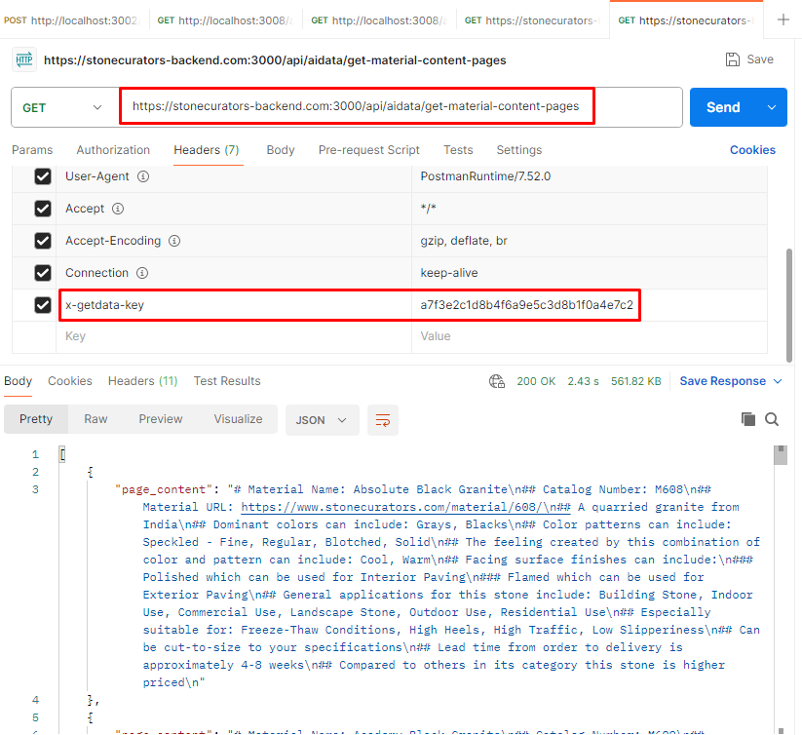

Example Response
[
{
"page_content": "# Material Name: Absolute Black Granite\r\n## Catalog Number: M608\r\n## Material URL: https://www.stonecurators.com/material/608/\r\n## A quarried granite from India\r\n## Dominant colors can include: Grays, Blacks\r\n## Color patterns can include: Speckled - Fine, Regular, Blotched, Solid\r\n## The feeling created by this combination of color and pattern can include: Cool, Warm\r\n## Facing surface finishes can include:\r\n### Polished which can be used for Interior Paving\r\n### Flamed which can be used for Exterior Paving\r\n## General applications for this stone include: Building Stone, Indoor Use, Commercial Use, Landscape Stone, Outdoor Use, Residential Use\r\n## Especially suitable for: Freeze-Thaw Conditions, High Heels, High Traffic, Low Slipperiness\r\n## Can be cut-to-size to your specifications\r\n## Lead time from order to delivery is approximately 4-8 weeks\r\n## Compared to others in its category this stone is higher priced\r\n"
},
…
]

4. Example Integration
Example using JavaScript (Fetch API)
const response = await fetch(
" https://stonecurators-backend.com:3000/api/aiData/getdatetime"
);
const data = await response.json();
console.log(data);

Example calling the Materials API
const response = await fetch(
" https://stonecurators-backend.com:3000/api/aiData/get-material-content-pages",
{
headers: {
"x-api-key": "a7f3e2c1d8b4f6a9e5c3d8b1f0a4e7c2"
}
}
);
const materials = await response.json();

5. Error Handling
Invalid API Key
{
"error": true,
"message": "Invalid API key"
}
Invalid Request
{
"error": true,
"message": " Failed to retrieve content pages from published materials"
}

